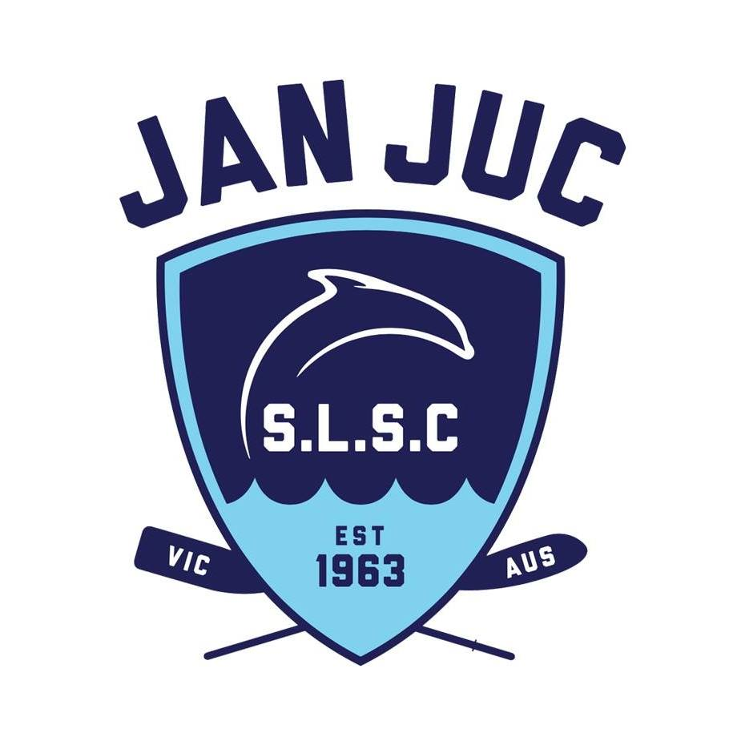 S-Badge Capability Confirmation 2022/2023

Complete this form for nippers who did attain a 2021/22 S-Badge and return to:
- Club Office at info@janjucsurfclub.com.au; or
- PO Box 179, Torquay, 3228.

Family Last Name:

S-Badge Information
To have obtained an S-Badge in 2021/22, a nipper must be able to swim the following distance in open water, in a continuous freestyle and not stop.
Age Group | S-Badge Swim Distance | Time Limit
U7 | Nil
U8 | Nil
U9 | 150 metres | 12 mins
U10 | 150 metres | 11 mins
U11 | 288 metres | 12 mins
U12 | 288 metres | 10 mins
U13 | 288 metres | 9 mins

Individual Nipper Certification Details
Nipper
Name
Still capable of swimming s-Badge distance achieved in 2021/22
Yes / No
Age Group

Parent/Guardian Certification
I certify that the child/ren listed above have maintained their ability to swim the S-Badge distance they achieved in 2021/22.

Parent/Guardian Name Signature

